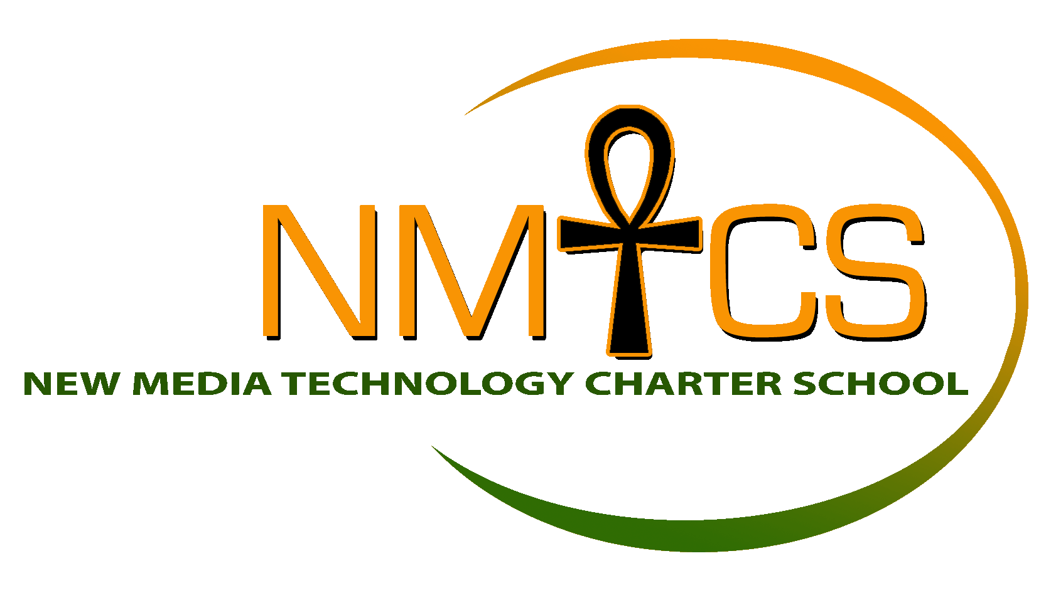New Media Technology Charter School

New Media Technology Charter School is a community of scholars and direct stakeholders who strive for compassion, practice and pursue resilience, engage in school and life with passion, are empowered by the process of challenging our assumptions about the way things are and can be, and act with dedication. New Media Technology Charter School’s mission is to provide a student-centered learning community that is project-based, technology-driven, and culturally affirming.

Job Title: High School Teacher, Full-Time
Position Overview

New Media Technology Charter School seeks a high school math teacher to focus on the development of an engaging math curriculum. The successful candidate will promote and nurture the education of scholars by planning and differentiating rigorous courses of study, using inquiry- based methods of teaching, monitoring, assisting with, and correcting, academic efforts connecting in-class learning and experiences outside of the classroom and school and creating a safe learning environment conducive to academic learning, exploration, and risk-taking. The teacher will stress rigor and well-designed assessments that challenge scholars to think critically and creatively.

Duties include:
- Developing and presenting lessons and learning in a variety of modalities including visual, auditory, kinesthetic, and tactile.
- Creating and implementing academically rigorous lessons and assessments
- Using data to drive instruction, remediation, and enrichment
- Creating a classroom environment that is safe and conducive to student learning
- Communicating high quality feedback about scholars academic, social, and behavioral progress
- Enforcing Student Code of Conduct and serving as a culture keeper for NMTCS’s mission
- Implement NMTCS’s curriculum and utilize classroom routines and procedures with consistency
- Develop rigorous lesson plans, homework assignments, and assessments
- Collaborate in grade level teams to discuss student work, share best practices, and ensure student mastery of standards
- Form and maintain relationships with scholars’ families, including phone calls and conferences
- Participate in on-going professional development in the spirit of continuous improvement
Competencies:
- Unwavering commitment to the mission, scholars, families, and communities of NMTCS and to the belief that all scholars can learn.
- Strong desire to teach in an urban environment/setting
- Commitment to an extended school day
- Desire to continuously learn and increase effectiveness as a teacher
- High level of receptivity to feedback to increase effectiveness

Qualifications:
- FBI, Child Abuse, and PA Criminal Clearances
- Inner City Teaching Experience preferred
- Bachelor’s Degree (in education) with experience, Master’s Degree (MEd), or alternative certification program (TFA or Teaching Fellowships)
- Experience with using emerging technology to drive classroom instruction preferred
- Experience with implementing project-based instruction preferred
- Goal driven, reflective, and driven to close our scholars achievement gaps
- Desire to work in school community that values compassion, resilience, engagement, empowerment, and dedication.
- The ability to motivate and challenge scholars and maintain a highly orderly classroom environment
- Receptiveness to feedback and a desire to continuously improve
- A strong sense of personal accountability for student achievement
- A belief that all scholars should be held to high standards
- A positive attitude and a drive for personal excellence

- Under the direct supervision of the school principal/designee
Interested candidates should submit a completed resume, letter of interest, and copy of certification as soon as possible to:
Susan Spencer, 8034 Thouron Avenue, Philadelphia, PA 19150 or sspencer@nmtcs.net

It is the policy of the New Media Technology Charter School to provide employment without regard to race, color, religion, national origin, sex, age or handicap as required by Title Vll, TitlelX and ADA.

